#######Aastha – [syaasthamadaan111@gmail.com######](mailto:syaasthamadaan111@gmail.com######)

Step 0: Adding content to ProductRecord.json file, indent=1 is used to write the data in json file in formatical way[with proper identation].

productRecord: contains basic details of product + it’s sales details like how many item of particular product is sold and time of purchase and against which transection Id it has been sold [storing using list format]

nested dictionary & list inside dictionary is implemented here.

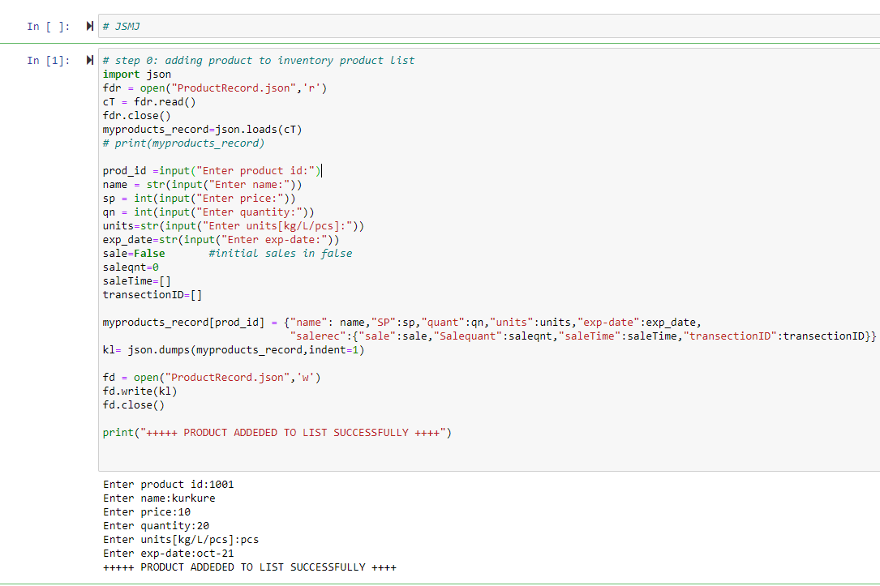

Step 1:

customer login: check new customer or existing on name & phno parameter.

If new customer and create space in data else append to the existing account.

Cutomer Cart is also maintained for billing and further cart,time of purchase,transection Id is appended in customer details.

In Cust_record.json

Catalogues display:reading data from product_record file

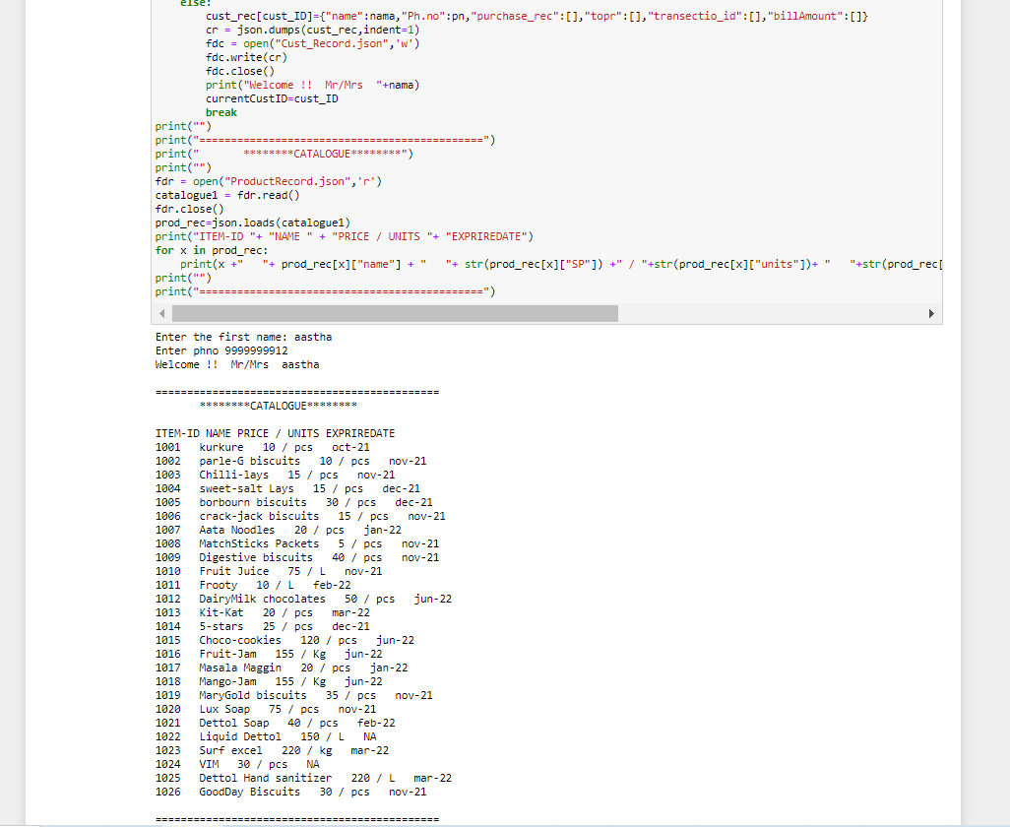

Step2:

billing using cart system [list implementation]

while purchasing and validations are taken into consideration[out of stock, item not found,added to cart]

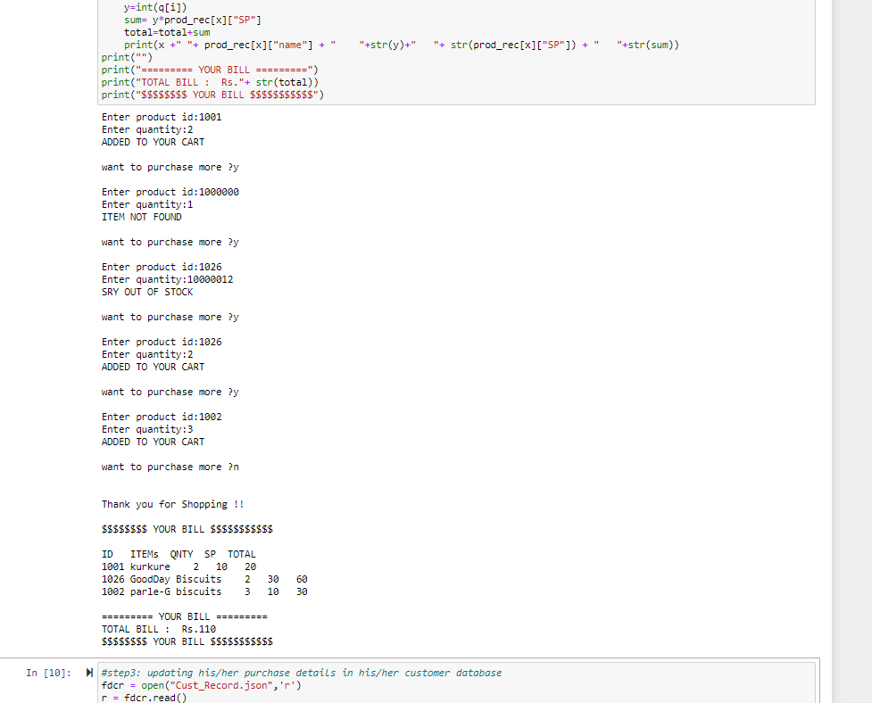

Step 3: customer purchase details updated to cutomer database

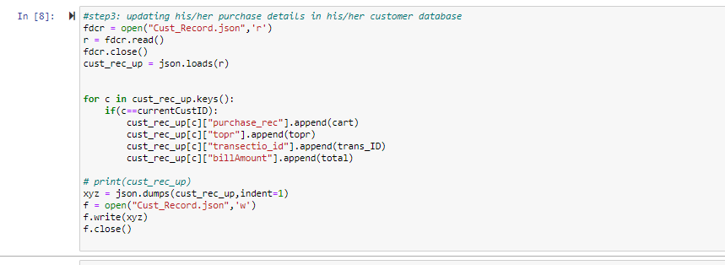

Step4: updating the sales details in salereccord.json [though it was not needed as all these details can be extracted through product detail json file which also contains sales details of product.]

This record is made considering futher scope to expand the project

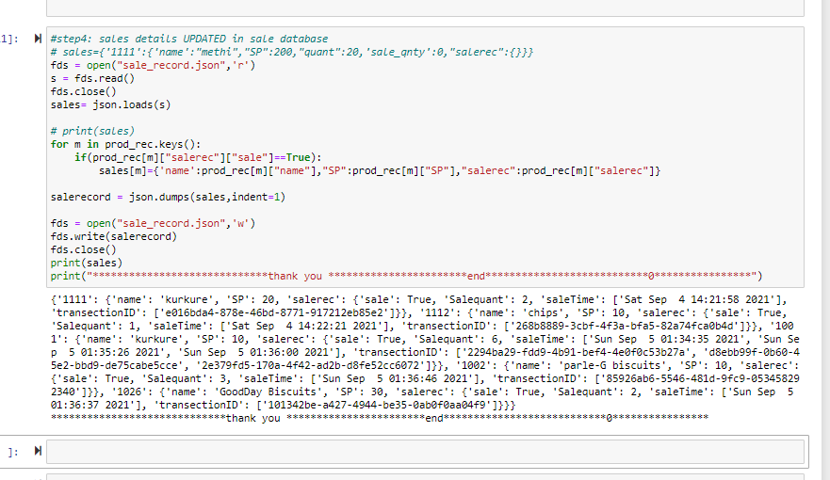

Thank you!!

Aastha

Suggestion to improve this project :

You may mail: syaasthamadaan111@gmail.com